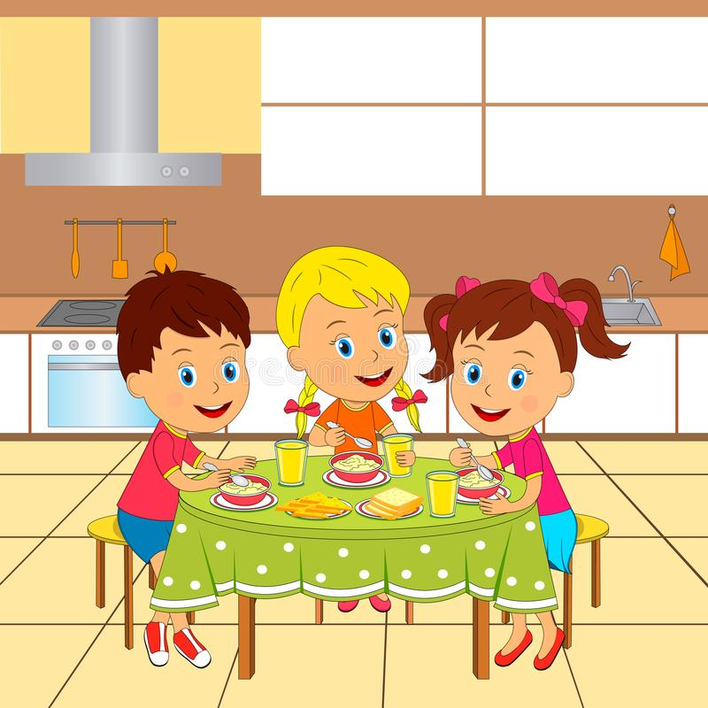

|  |  |
| --- | --- |
| C:\Users\серый\Desktop\pngtree-carrot-cartoon-png-image_1724297.jpg | C:\Users\серый\Desktop\kartofel-belyj-mytyj-875x875.jpg |
| C:\Users\серый\Desktop\luk_kartinka_dlya_detey_2_09173706 (1).jpg | C:\Users\серый\Desktop\png-transparent-kolobok-fairy-tale-character-the-gigantic-turnip-babushka-food-text-hand.png |

